In August, 2006 while sealing openings to prevent rodent ingress, I noticed scorch marks around the adaptor plate that connects the heating duct to the furnace on a Trail Bay fifth wheel trailer, model TB5534CI. The cost of returning to the dealer (450 km. distant) and the likelihood that the dealer would not be able to spend the time to accomplish the repair to my satisfaction meant that I did the repairs myself and no warranty claim was attempted nor will be. I pass on this report in the hope that somebody will be forewarned and inspect their rig and a tragedy be prevented.

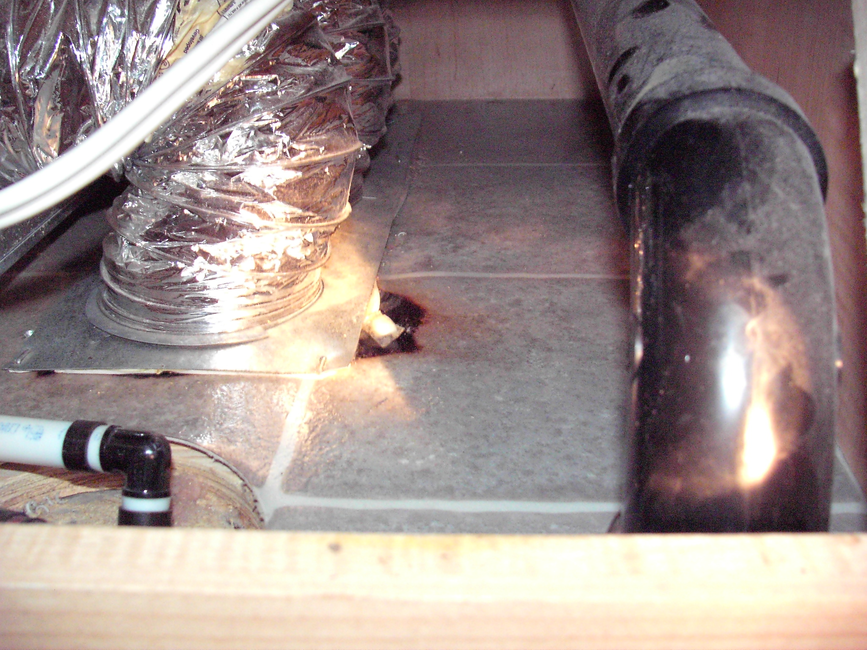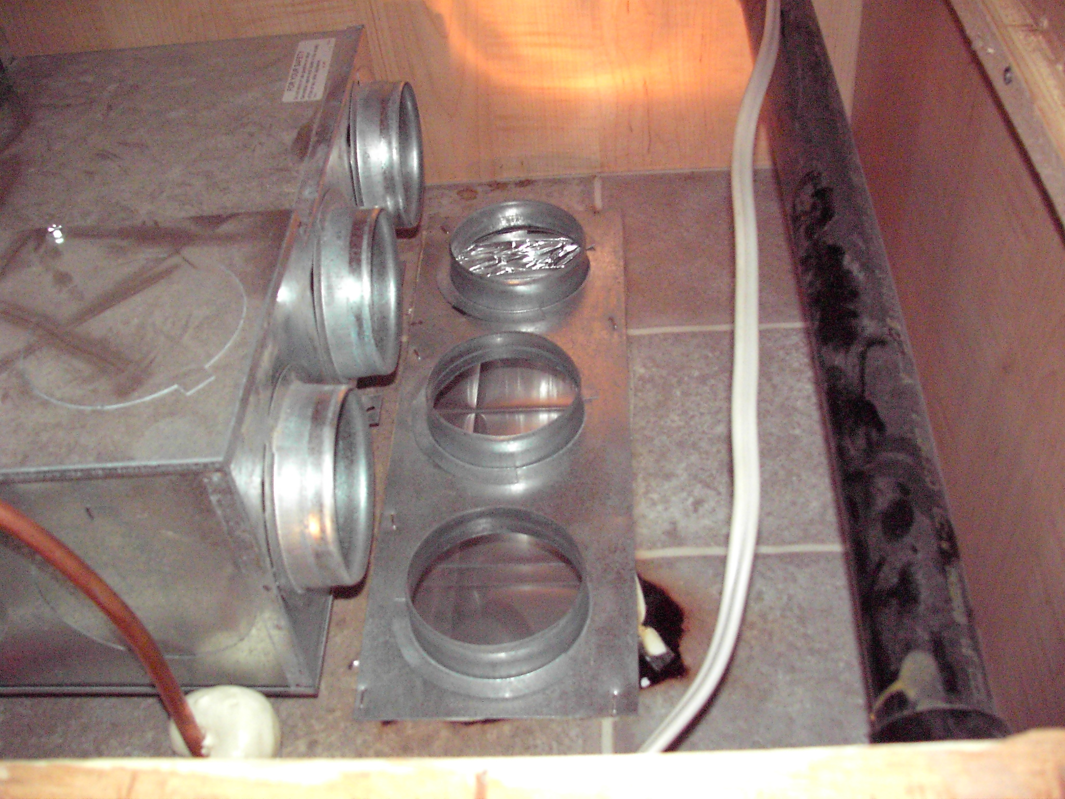

Closer inspection revealed several defects that may have contributed to the scorch marks:

There was a twisted gasket on the adaptor flange, causing a gap in sealing; there was an indentation from a staple gun misfire, but the staple was not present and there were no holes through the flange where a staple would have pierced it; the opening in the floor was smaller than the area required by the three round duct connectors.

On the left, below, this picture of the underside of the adaptor plate shows the gap in the gasket. The picture on the right is a view of the opening through the floor as it appeared upon removal of the adaptor flange and before any remediation was started. The edge of the opening was (mostly) covered with foil tape in the factory installation.
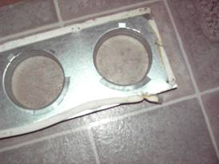
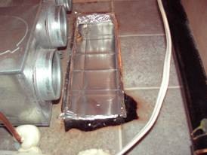

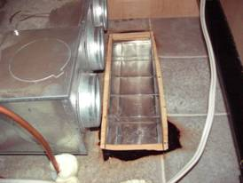
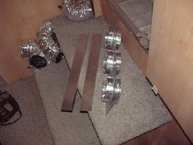

The view to the left, above, shows the factory foil tape removed, the opening lengthened to no longer obstruct the duct opening and the linoleum flooring material cut back from the edge of the floor opening. The picture on the right shows the adaptor plate modified to extend the pipe more or less even with the bottom of the floor. The circumference of the duct openings in the adaptor flange have been sealed with foil tape.

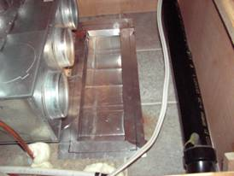
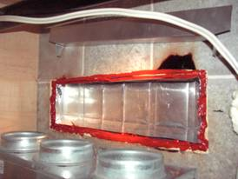
The picture on the left, above, shows the opening with L-shaped pieces of sheet metal all around, gapped approximately 1/8” from the plywood of the sub-floor. The sheet metal “L” is attached to the sheet metal duct with foil tape. The gap between the sheet metal and the plywood sub-floor has been filled with high temperature silicone RTV as has the gap left by cutting back the flooring material from the edge of the opening. The right picture, above, is of the opening protected by U-shaped pieces of sheet metal. These have been attached to the duct and each other with foil tape. The outer edge of the adaptor flange has been marked on the sheet metal as a guide for application of the high temperature RTV shown below.

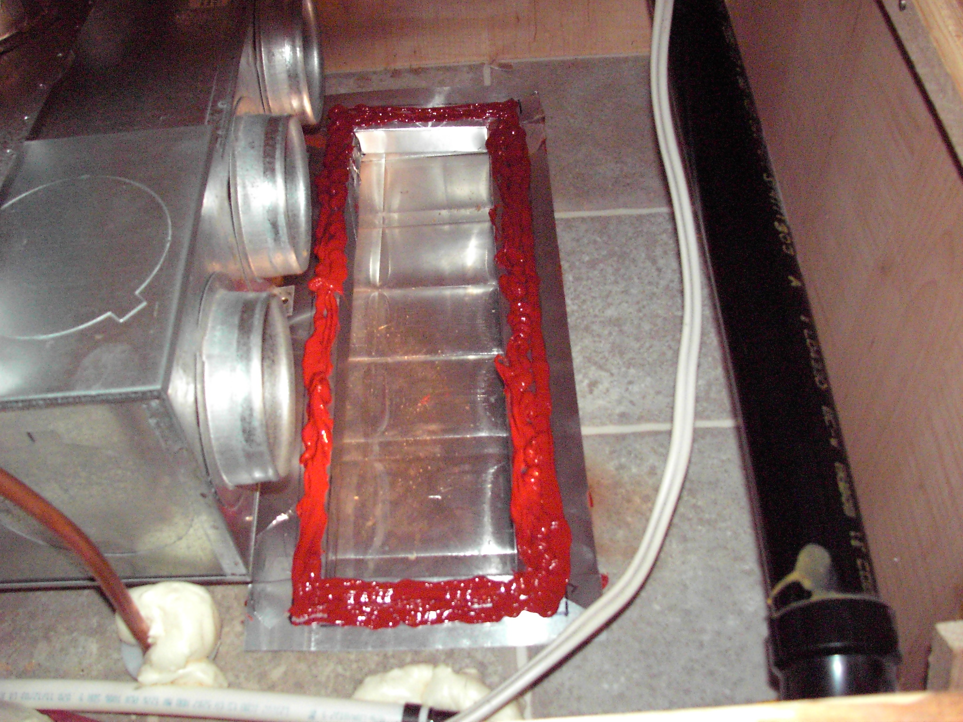

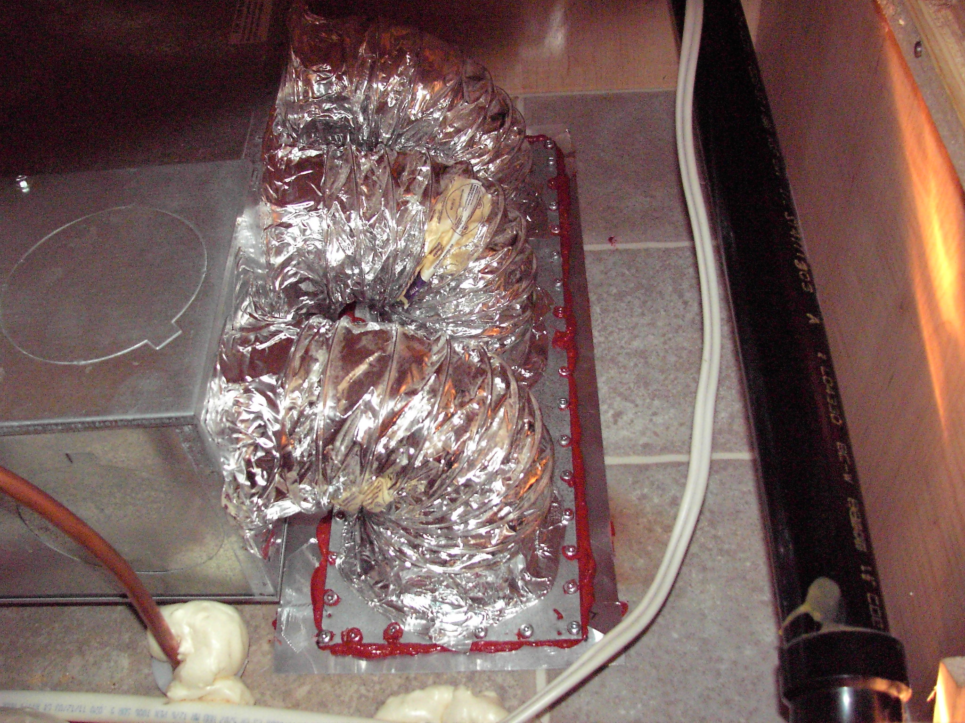

The completed installation shown above with closely spaced #8 sheet metal screws attaching the heat duct adaptor flange and working in conjunction with the high temperature silicone RTV caulking to prevent future hot air leakage and scorching.

